Design Overview
The business layer combines two sales datasets into one integrated 3NF data model:
- Offline sales dataset: contains customers, products, suppliers, branches, sellers, payments, and sales transactions.
- Online sales dataset: contains customers, products, suppliers, couriers, customer addresses, payments, and online orders.
If the same entity exists in both datasets, it is stored in one common table. For example:
- Customer data from both datasets is stored in the CUSTOMER table.
- Sellers from offline sales and couriers from online sales are stored in the EMPLOYEE table.
- The column EMPLOYEE_ROLE is used to distinguish between a seller and a courier.
- Products, suppliers, payments, and other shared entities are also stored only once.
The model follows Third Normal Form (3NF). This means that each table represents one business entity, duplicate data is reduced, and relationships between tables are created using primary keys and foreign keys.
The 3NF model is shown in the diagram below.

Slowly Changing Dimensions (SCD)
A Slowly Changing Dimension (SCD) is a technique used to track changes in dimension data over time.
For example, customer information may change. A customer can update their email address, gender, phone number, or home address. If the old information is overwritten, the business loses the history of previous values.
SCD helps preserve this history for reporting and analysis.
This project uses SCD Type 2. In SCD Type 2, when a tracked attribute changes:
The old record is closed and marked as inactive.
A new record is inserted with the updated information.
Both old and new versions remain in the table.
This makes it possible to analyze sales using the customer information that was valid at the time of each transaction.

Naming Conventions
The following naming conventions are used in the business layer:
Surrogate key: column_name_SK
Example: CUSTOMER_SK, PRODUCT_SK, EMPLOYEE_SK
Natural key: coulumn_name_SRC_ID
Example: CUSTOMER_ SRC_ID , PRODUCT_ SRC_ID, ORDER_ SRC_ID
SCD Type 2 table: DIM_CUSTOMER_H
A surrogate key is a technical key created in the data warehouse. It is used as the primary key of the table.
A natural key is the original business identifier from the source system. For example, a customer ID from the source dataset is a natural key.
Foreign keys in child tables reference the surrogate keys of related tables.

Source Triplet and Audit Columns
Each table contains source triplet columns to show where the data came from:
SOURCE_ENTITY – source table or file name
SOURCE_SYSTEM – source system name, such as Online Sales or Offline Sales
Each table also contains audit columns:
INSERT_DT – date and time when the record was inserted into the business layer
UPDATE_DT – date and time when the record was last updated
These columns help track data lineage and support ETL monitoring.

SCD Type 2 Entity
The Customer entity was selected for SCD Type 2 because customer information can change over time.
The SCD Type 2 customer table is named:
CUSTOMER
The table stores customer details such as:
- Customer name
- Email address
- Gender
- Phone number
- Address
- City or region
When one of the tracked attributes changes, a new customer record is created. The previous record is kept for historical purposes.
The following SCD Type 2 columns are included:
- START_DT – date when the record version became valid
- END_DT – date when the record version stopped being valid
- IS_ACTIVE – indicates whether this is the current (active) version of the customer record. Y = current, N = historical.
For example, if a customer changes their address, the old address record receives an END_DT and IS_ACTIVE = N. A new record is inserted with the new address, a new START_DT, and IS_ACTIVE = Y.
This approach keeps the full history of customer changes and allows accurate historical reporting.

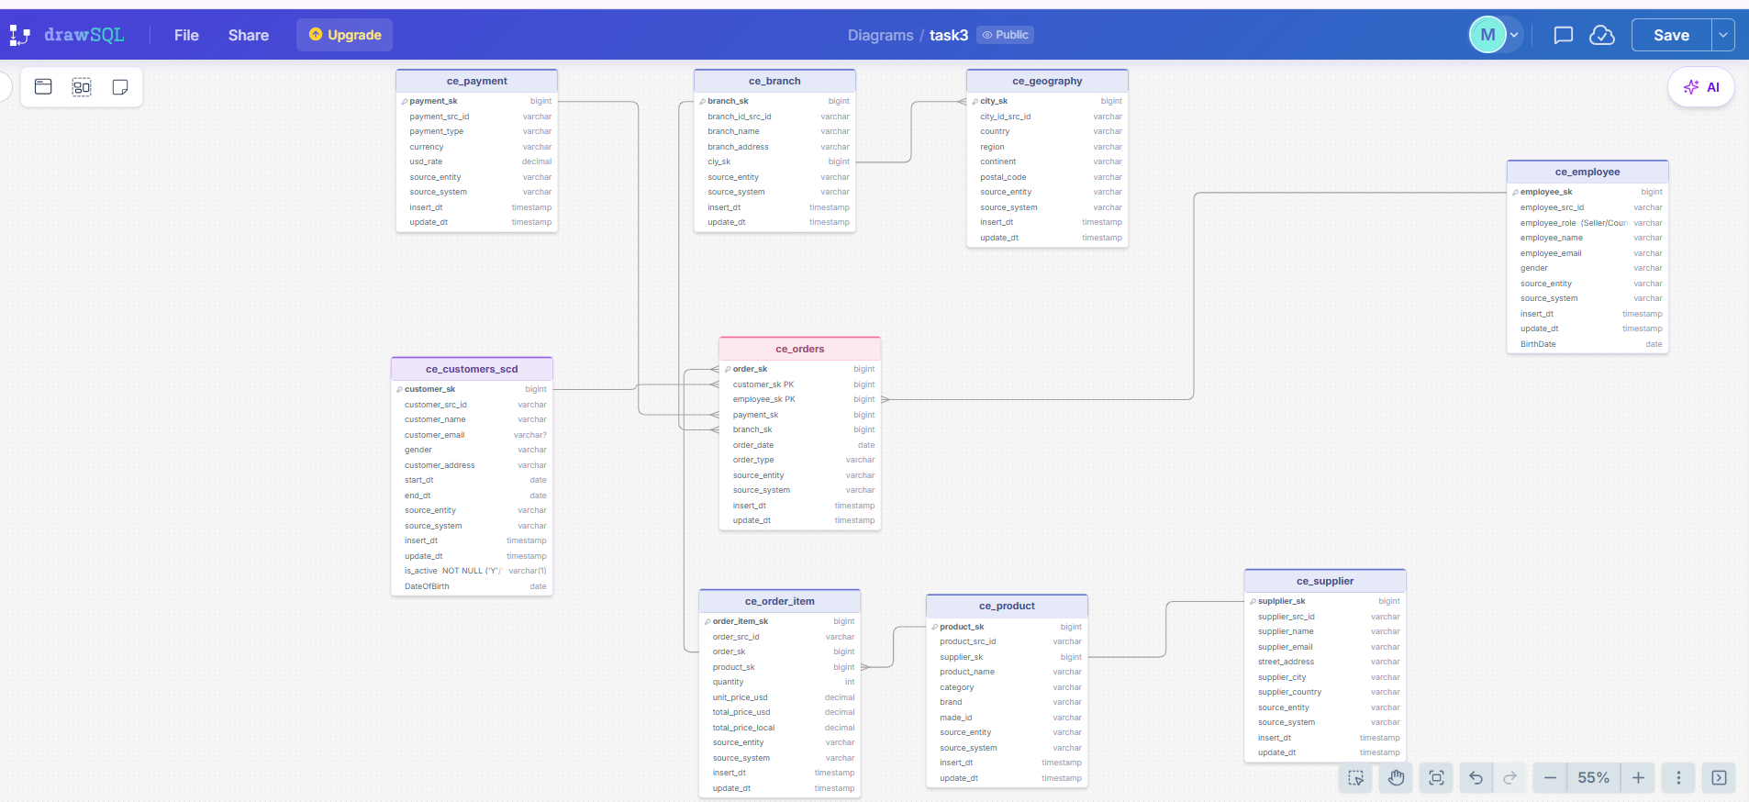

Link to the diagram https://drawsql.app/teams/muhammad-s/diagrams/task3

